Why PriorityQueue not sorted completely?
A PriorityQueue is not fully sorted because its primary objective is efficiency in retrieving only the highest (or lowest) priority element, not maintaining a complete ordering of all elements

Can PriorityQueue store null?
No, a Java PriorityQueue cannot store null elements. Attempting to add a null element using the add() or offer() methods will result in a NullPointerException

How heap stored in array?
A heap is stored in an array by mapping the nodes of a complete binary tree to the array's indices in a level-by-level, left-to-right order

Why ArrayDeque faster than LinkedList?
ArrayDeque is generally faster than LinkedList primarily due to better locality of reference and lower memory overhead.

2.5 Queue Implementations (Deep Internal Working)
Before going deep:
Queue = FIFO (First In First Out)
Like people standing in a line.
Now let’s break down the major Queue implementations internally.

1️⃣ PriorityQueue
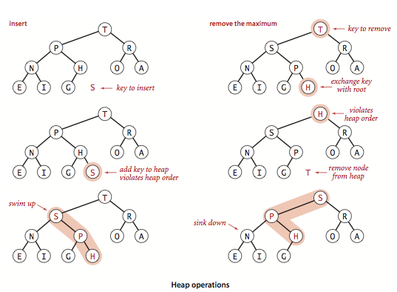
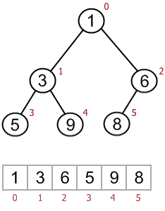
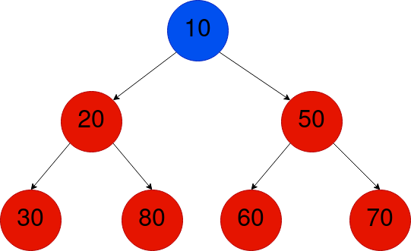
4
📌 Internal Structure
PriorityQueue internally uses:
Binary Heap (Min Heap by default)
And stored inside:
Object[] queue;
So internally it is:
Array + Heap property

🔥 How It Works (Step-by-Step)
Example:
PriorityQueue<Integer> pq = new PriorityQueue<>();
pq.add(50);
pq.add(10);
pq.add(40);
Step 1: Insert 50
Stored at index 0.
[50]
Step 2: Insert 10
Placed at end → then heapify upward.
[50, 10]
Heapify:
10 < 50 → swap
[10, 50]
Step 3: Insert 40
[10, 50, 40]
Compare with parent (10) → OK.
Final heap:
10
/ \
50 40

⏱ Time Complexity
Operation | Time
add | O(log n)
poll | O(log n)
peek | O(1)

⚠ Important
- Does NOT maintain insertion order
- Does NOT allow null
- Sorted based on:
  - Comparable
  - OR Comparator

2️⃣ ArrayDeque
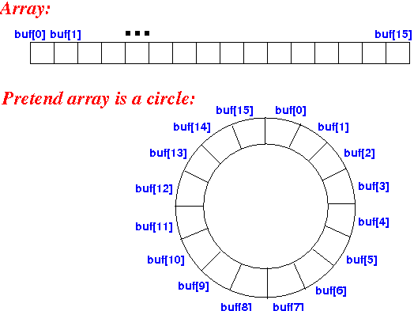
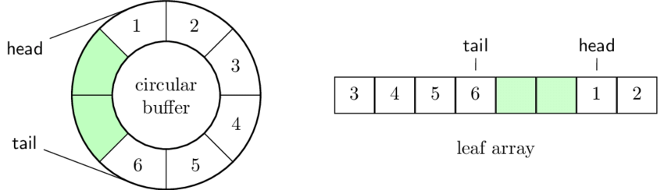

4
📌 Internal Structure
Uses:
Resizable Circular Array
Internally maintains:
head index
tail index
So it's:
Circular Buffer

🔥 How It Works
Imagine capacity = 5
[ _ _ _ _ _ ]
0 1 2 3 4
Add elements:
dq.addLast(10);
dq.addLast(20);
dq.addLast(30);
Now:
[10 20 30 _ _]
head=0
tail=3
Remove first:
dq.removeFirst();
Now:
[10 20 30 _ _]
head=1
tail=3
It doesn’t shift elements.
It just moves pointer.
That’s why it’s very efficient.

⏱ Time Complexity
Operation | Time
addFirst | O(1)
addLast | O(1)
remove | O(1)
Faster than LinkedList for queue usage.

⚠ Why Better than LinkedList?
- No node objects
- No pointer overhead
- Better cache locality
- Less memory

3️⃣ LinkedList (as Queue)
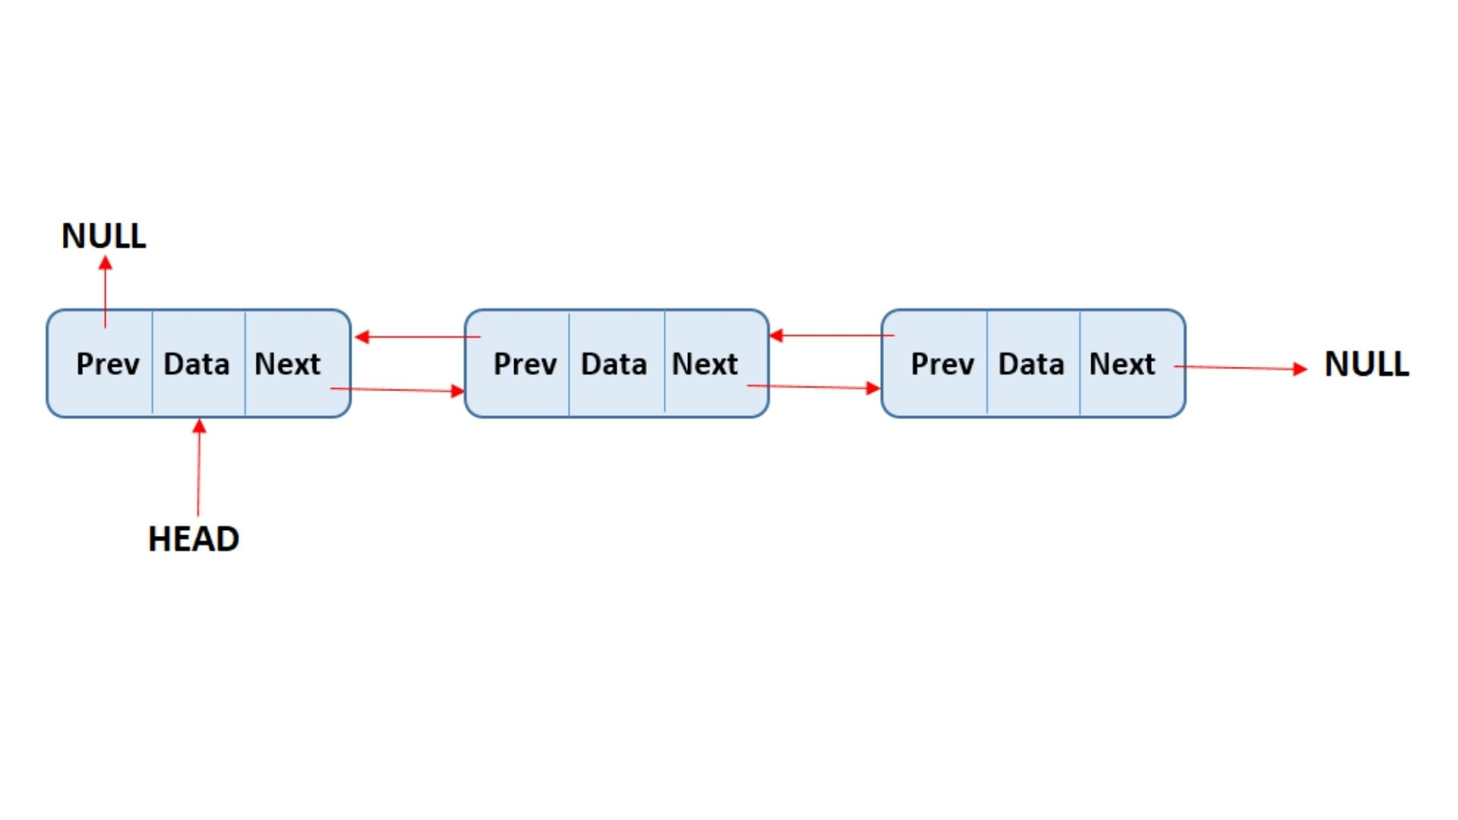
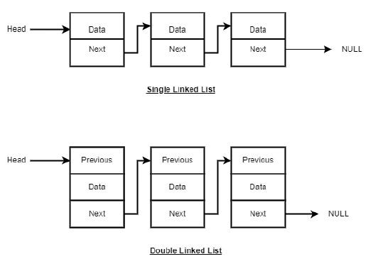
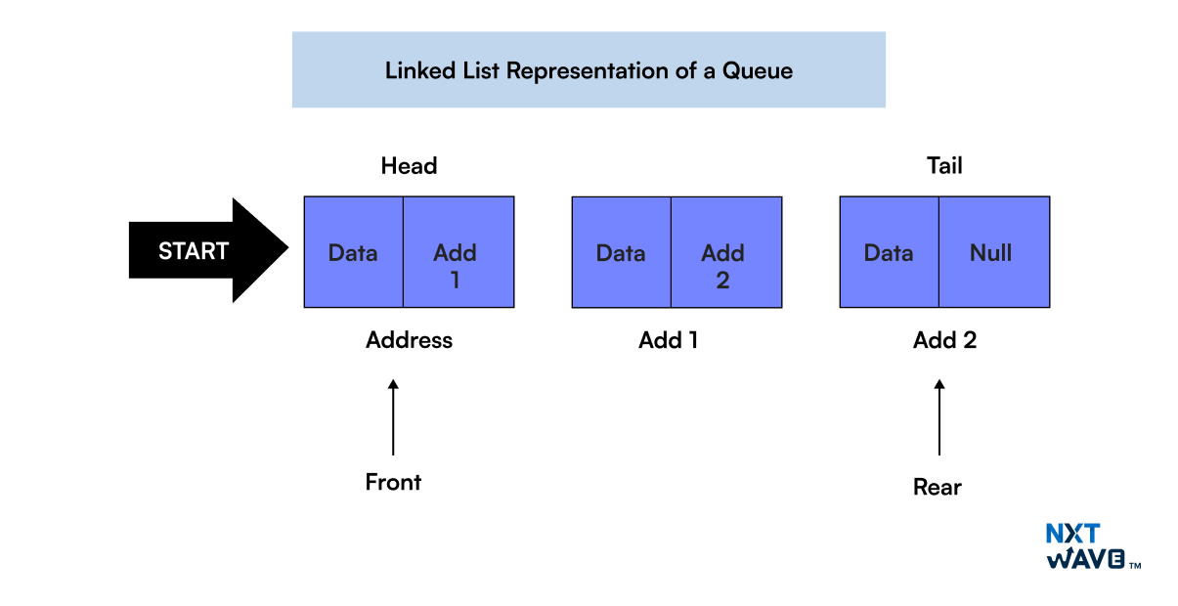
4
Internally:
Doubly Linked List
Each node contains:
data
next
prev
Queue operations:
- add → tail
- remove → head

⏱ Complexity
Operation | Time
add | O(1)
remove | O(1)
But:
❌ More memory
❌ More object creation
❌ Slower than ArrayDeque

4️⃣ Blocking Queues (Multithreading)
Used in concurrency.
Examples:
- ArrayBlockingQueue
- LinkedBlockingQueue
- PriorityBlockingQueue
Used in:
Producer-Consumer Pattern
Thread Pools
Executor Framework
These are thread-safe.

🧠 Queue vs Deque
Feature | Queue | Deque
Insert | One end | Both ends
Remove | One end | Both ends
Example | PriorityQueue | ArrayDeque

🎯 When To Use What?
Situation | Use
Simple FIFO | ArrayDeque
Need priority | PriorityQueue
Multithreading | BlockingQueue
Rare case | LinkedList

🔥 Interview Trap Questions
- Why ArrayDeque faster than LinkedList?
- Why PriorityQueue not sorted completely?
- Can PriorityQueue store null?
- How heap stored in array?
- What happens during resize?

2.6 Map Implementations (Deep Internal Working)
Now we enter the most important topic in Java Collections.
If you understand Map deeply → you understand 60% of Collections.

🔹 What is Map?
- Stores key–value pairs
- Keys must be unique
- Values can be duplicate
- Not part of Collection hierarchy (separate branch)

1️⃣ HashMap (Most Important)
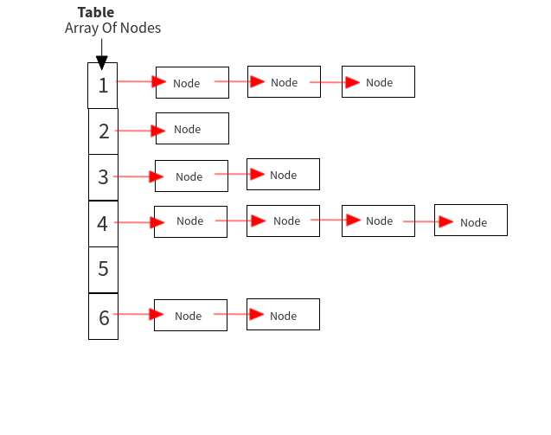
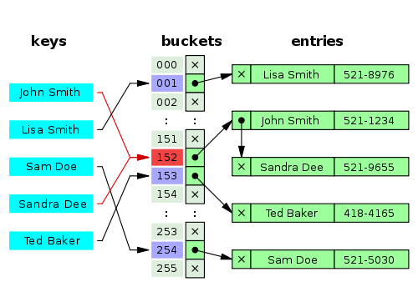
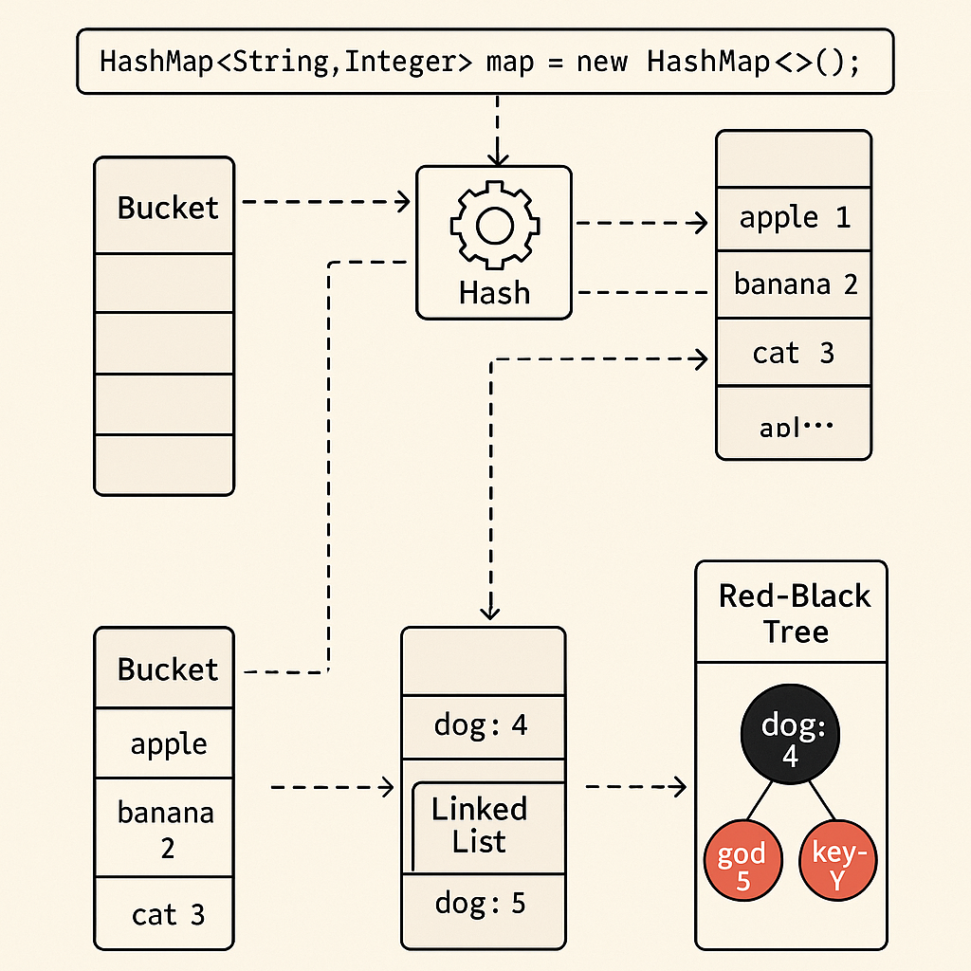
4
📌 Internal Structure
Internally:
Node<K,V>[] table;
Each bucket contains:
class Node<K,V> {
int hash;
K key;
V value;
Node<K,V> next;
}
So structure is:
Array + LinkedList (or Tree after Java 8)

🔥 How put() Works (Step-by-Step)
Example:
HashMap<String, Integer> map = new HashMap<>();
map.put("Lakshay", 101);
Step 1: Calculate hash
int hash = key.hashCode();
Step 2: Find index
index = (n - 1) & hash;
(n = array length)

Step 3: Check bucket
If bucket empty → insert
If not empty:
- Compare hash
- Compare equals()
- If same → replace value
- Else → go to next node (collision)

🔥 Collision Handling
Before Java 8:
- LinkedList
After Java 8:
- If bucket size > 8 → convert to Red-Black Tree
This improves worst-case from:
O(n) → O(log n)

🔥 Resize & Rehashing
Default:
- Initial capacity = 16
- Load factor = 0.75
Resize condition:
size > capacity × loadFactor
So:
16 × 0.75 = 12
When 13th element inserted → resize to 32.
Then rehash all elements.

⏱ Time Complexity
Operation | Average | Worst
put | O(1) | O(log n)
get | O(1) | O(log n)
remove | O(1) | O(log n)

⚠ Important Rules
- If you override equals(), you MUST override hashCode()
- Keys should be immutable
- HashMap allows:
  - One null key
  - Multiple null values

2️⃣ LinkedHashMap
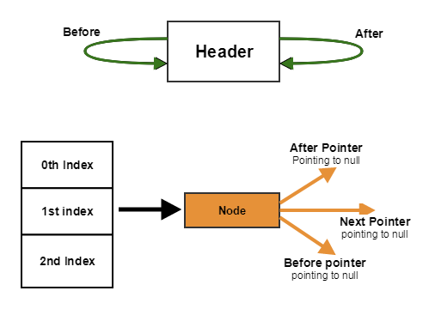
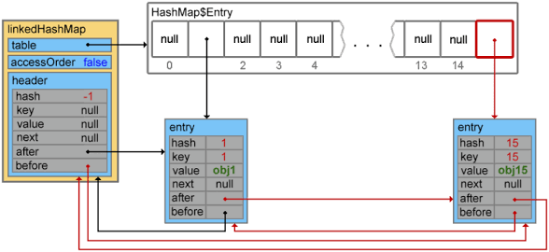
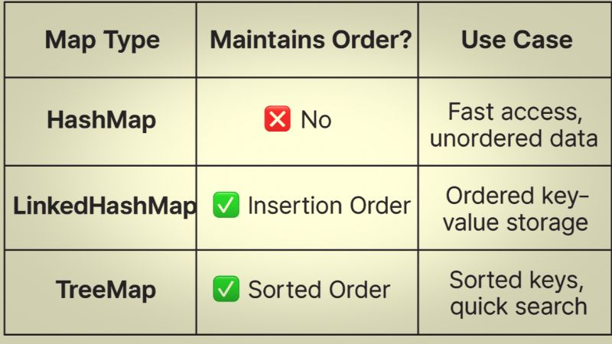
4
📌 Internal Structure
Uses:
HashMap + Doubly Linked List
Maintains:
- Insertion Order
OR
- Access Order (for LRU)

🔥 Special Feature: LRU Cache
new LinkedHashMap<>(16, 0.75f, true);
true → access-order mode
Used to implement:
Least Recently Used (LRU) Cache

⏱ Complexity
Same as HashMap:
O(1) average.
Slightly slower due to linked structure.

3️⃣ TreeMap

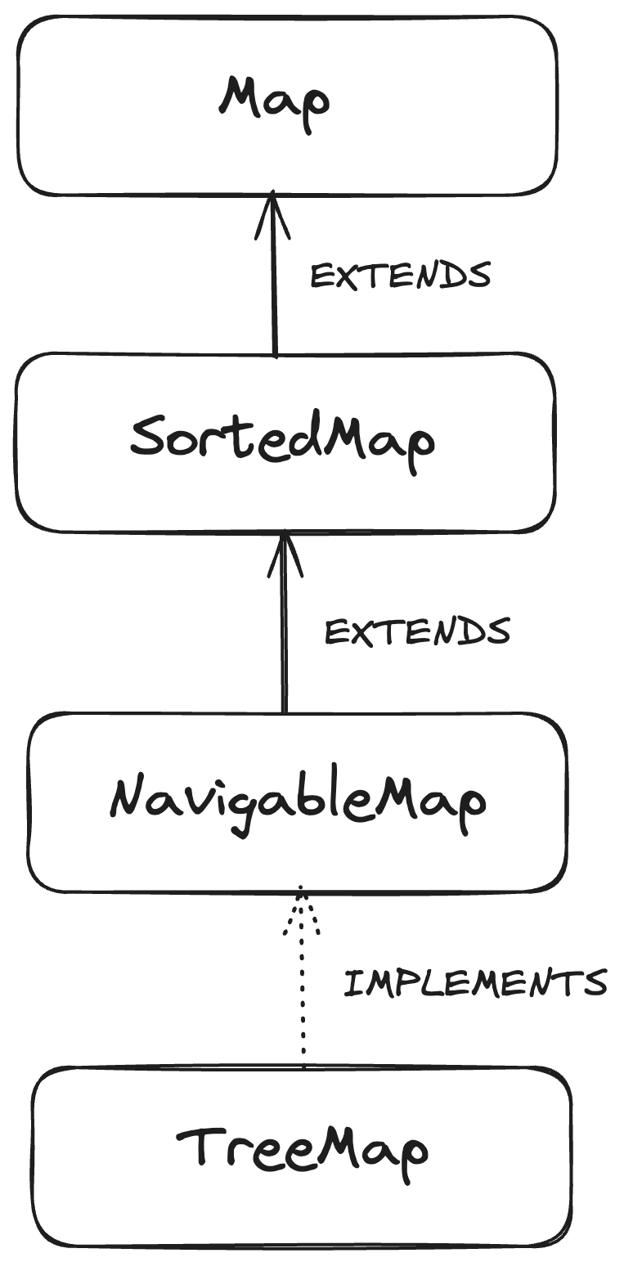
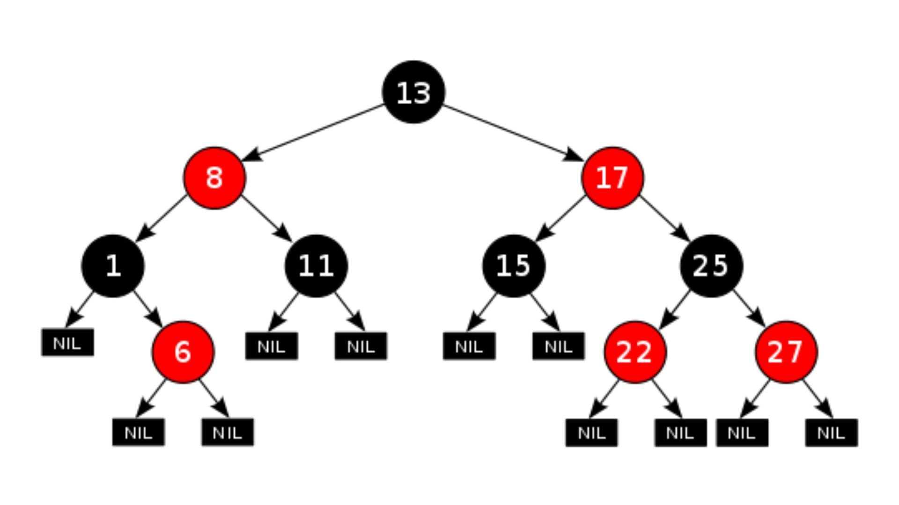
📌 Internal Structure
Uses:
Red-Black Tree (Self-balancing BST)
Sorted based on:
- Comparable
OR
- Comparator

🔥 How It Stores Data
When inserting:
map.put(50, "A");
map.put(10, "B");
It places based on ordering.
Then balances tree using:
- Rotations
- Color flips

⏱ Time Complexity
Operation | Time
put | O(log n)
get | O(log n)
remove | O(log n)

⚠ Important
- Does NOT allow null key
- Sorted keys
- Slower than HashMap

4️⃣ Hashtable (Legacy)
- Thread-safe
- No null key/value
- Slower (synchronized)
Now mostly replaced by:
ConcurrentHashMap

5️⃣ ConcurrentHashMap (Advanced)
Used in multithreading.
Java 8:
- Uses CAS (Compare-And-Swap)
- Bucket-level locking (not whole map lock)
Much faster than Hashtable.

🔥 HashMap vs LinkedHashMap vs TreeMap
Feature | HashMap | LinkedHashMap | TreeMap
Order | ❌ No | ✅ Insertion/Access | ✅ Sorted
Speed | Fastest | Slightly slower | Slowest
Internal DS | Array + List/Tree | HashMap + DLL | Red-Black Tree
Null Key | 1 allowed | 1 allowed | ❌ Not allowed

🔥 Very Important Interview Questions
- Why HashMap capacity must be power of 2?
The HashMap capacity in Java must be a power of 2 to allow for faster index calculation using bitwise operations and to ensure an efficient and uniform distribution of keys
- Why equals() & hashCode() must be overridden together?
  - Maintaining the Contract: If two objects are equal (a.equals(b) is true), they must have the same hashCode().
  - If equals() is overridden without hashCode(), equal objects will likely have different hash codes, violating this rule.
  - Hash-Based Collection Integrity: HashMap and HashSet use hashCode() to determine the "bucket" to store an object. If you override only equals(), two logically equal objects might be placed in different buckets, meaning HashSet.contains() or HashMap.get() will fail to find them.
  - Performance: Proper hashing helps distribute objects across buckets, reducing collisions and improving performance.
  - Consistency: Violating this contract results in unpredictable behavior, such as duplicate entries in a Set or an inability to retrieve keys from a Map.
- What happens during resize?

- Why treeify threshold is 8?
The TREEIFY_THRESHOLD is set to 8 in Java's HashMap to balance the trade-offs between the memory overhead of a tree structure and the performance benefits it provides during high hash collisions. The threshold is based on statistical probability and performance considerations
- Difference between fail-fast and fail-safe iterator?
Fail-fast iterators immediately throw ConcurrentModificationException if a collection is structurally modified during iteration, traversing the original data. Fail-safe iterators work on a clone of the collection, allowing concurrent modifications without exceptions. Fail-fast is used for non-thread-safe collections (e.g.ArrayList), while fail-safe is used for concurrent collections (e.g.CopyOnWriteArrayList).

